|  |  |  |  |  |
| --- | --- | --- | --- | --- |
| **Description of Test** | **Test data to be used** | **Expected outcome** | **Actual outcome** | **Comments and intended actions** |
| Navigation bar: Black box testing, Functional testing (Integration testing) | No input is needed now, check to see if the navbar has passed all the tests. Black box testing lets us examine the functionality from the user’s end. Testing integration ensures us that the nav bar seamlessly interacts with the links. For example, clicking on the energy page should take us to the energy page with minimum page load time. | The navigation bar has 5 sections and then the user’s profile. On the left, it has the company’s logo and on the right it has home, about us, energy, carbon calc and schedule. When hovering the writen darkens from a light black to a harsh black. When clicking on the link we should expect it to take us to that page. | * Nav bar works (all links to us to the correct page) * 1-3 sec load time | None |
| Homepage: White box testing, Black box testing: Functional and Integration testing, Unit testing | No data is needed as we are checking to see if the buttons work by doing black box testing. Also, ensuring the buttons co-operate with the rest of the website by doing integration testing. Using white box testing, we check if the code is logically correct (Also checking for syntac errors). | The homepage should be shown correctly, confirm all buttons work and pass WCAG. When the user clicks on ‘Log in’ or ‘Sign in’ it takes them to that page, If the user wants to learn more about ‘Green energy’ it should lead them to the energy page. Carbon calc naviagtes them to the carbon page. | * The log in and sign up now buttons work accordingly however the green energy and carbon one does not as I have no created a href link to the page * Page is properly integrated | Add a href link to both green energy and carbon calc buttons to take users to the desired page. |
|  |  |  |  |  |
|  |  |  |  |  |
|  |  |  |  |  |
|  |  |  |  |  |

|  |  |  |  |  |
| --- | --- | --- | --- | --- |
| **Content** | **Type** | **Source** | **Purpose** | **Date** |
| Background Picture/ Home | Image | <https://www.istockphoto.com/photo/solar-energy-panels-and-wind-turbines-gm493188080-76767435> | To make the website more appealing to the customer and give them an idea of what the website will hold. | First obtained during the design phase  11/03/2025 |
| Green energy | Image | <https://www.magazine.unimore.it/site/home/notizie/articolo820066054.html> | Letting the user know what the section is about without having to read the information. | First obtained during the design phase  11/03/2025 |
| Solar Panel | Image | <https://solarplanet.uk/comprehensive-guide-to-solar-panel-sizes-and-their-significance/> | Gives the user an idea of what the solar panel would look like. |  |
| EV charging  Stations | Image | <https://blog.evbox.com/uk-en/how-to-use-fast-charging-stations> | It offers the user a visual representation of how their car would look like with the product. |  |
| Smart home energy | Image | <https://theconversation.com/uk/topics/online-safety-bill-100144> | It helps the user envision what their home could be. |  |
| Carbon Footprint | Image | <https://energise.energy/world-ev-day/> | Visually appealing. |  |
| Rewards | Image | <https://www.shutterstock.com/search/laurel-cartoon?image_type=vector&page=17> | Visually appealing. |  |
| Manage | Image | <https://www.shutterstock.com/search/laurel-cartoon?image_type=vector&page=17> | Visually appealing. |  |
| Schedule consultation | Image | <https://www.vecteezy.com/free-videos/2d-animation-doctor?page=5> | Visually appealing. |  |
| Schedule installation | Image | <https://www.vecteezy.com/free-videos/2d-animation-doctor?page=5> | Visually appealing. |  |

**Version 1**

Initial homepage

Functional requirement

The system shall display the homepage with navbar, main section, and footer.

There are no inputs of data needed on this page only if the user wishes to log in or sign up. The user should be taken to the necessary page when clicking on the links to other pages. For example, when clicking on the "Schedule" button, the booking page should be displayed immediately.

Navigation bar consists of:

* Home
* About
* Energy
* Carbon FP
* Schedule
* Account

Index.html

Currently, this is my homepage where the user can access the nav bar efficiently. It also allows the user to log in and sign up without any confusion or hardship. It is a clear and easy design where customers can access what they want.

|  |  |
| --- | --- |
| **The design** | **The prototype** |
|  |  |

Rolsa technologies was built with a fundamental focus on user experience. It boasts a well-designed interface which includes key UI/UX features that make it useful and easy to use. The aim was to create a desirable website that functions whilst looking aestherically pleasing. I believe this website strongly repersents the company Rolsa tech due to consistent visual elements which showcase a general idea of what the company is about.

When hovering buttons the button turns #003366

In my next version, I will enhance user privacy in line with GDPR requirements. This includes adding a robust and user-friendly mechanism which will allow users to accept or decline non-essential cookies.

Sign up / Log in

|  |  |
| --- | --- |
| The design | The prototype |
|  |  |

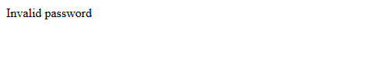

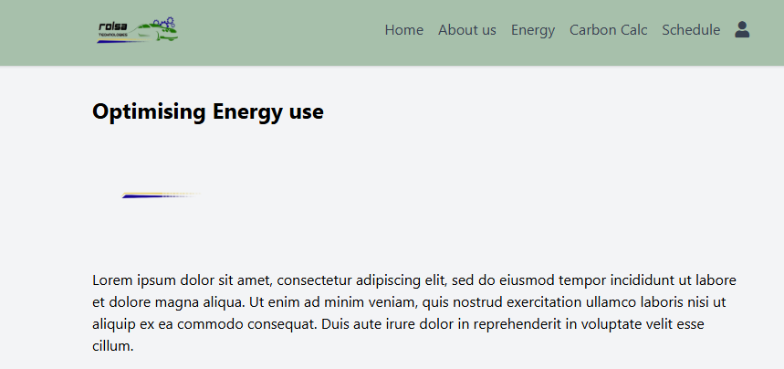

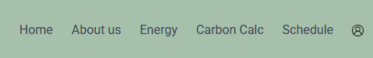

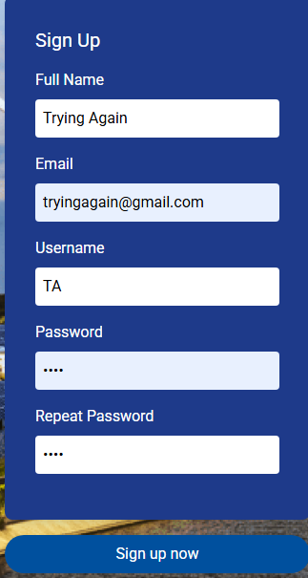

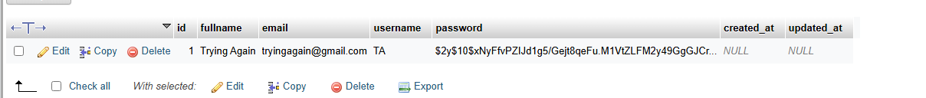

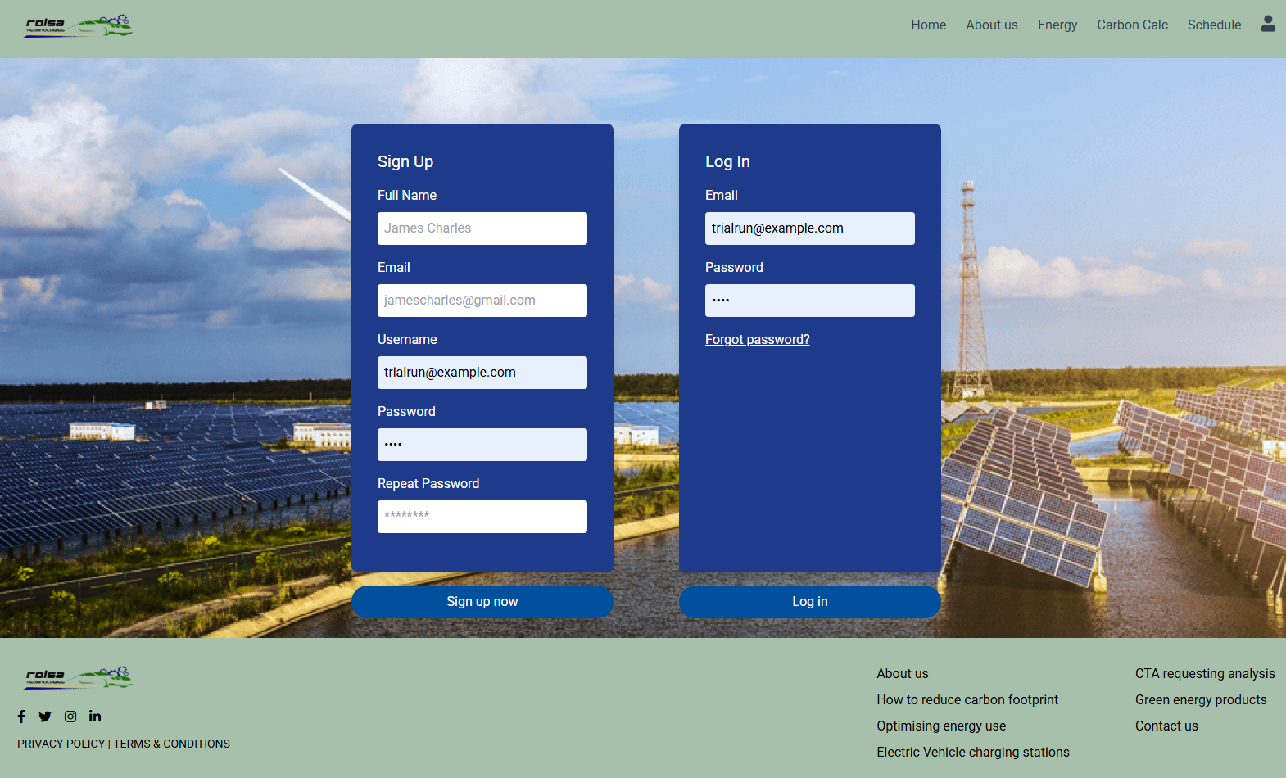

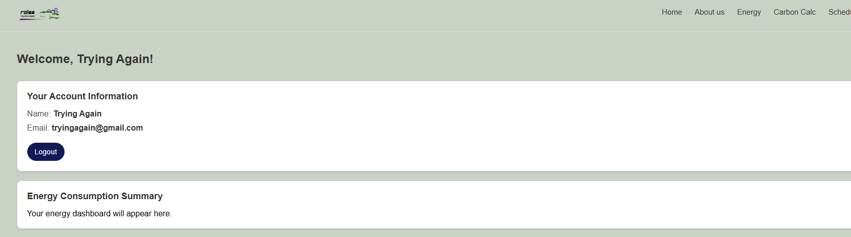

Pages to do:

Welcome user [dashboard.php]

Learn more[ D7]

CF calc

SCHEDULE [ Installatins] [Consultations]